**DSA MINI PROJECT DIAGRAMS**

**BY:  
PES1UG22CS322 – MAHIMA A**

**PES1UG22CS344 – MEGHA BHAT**

**PES1UG22CS345 – MEGHA JS**

**PES1UG22CS337 – SRAVYA MATTA**

**ADD SONG TO PLAYLIST:**

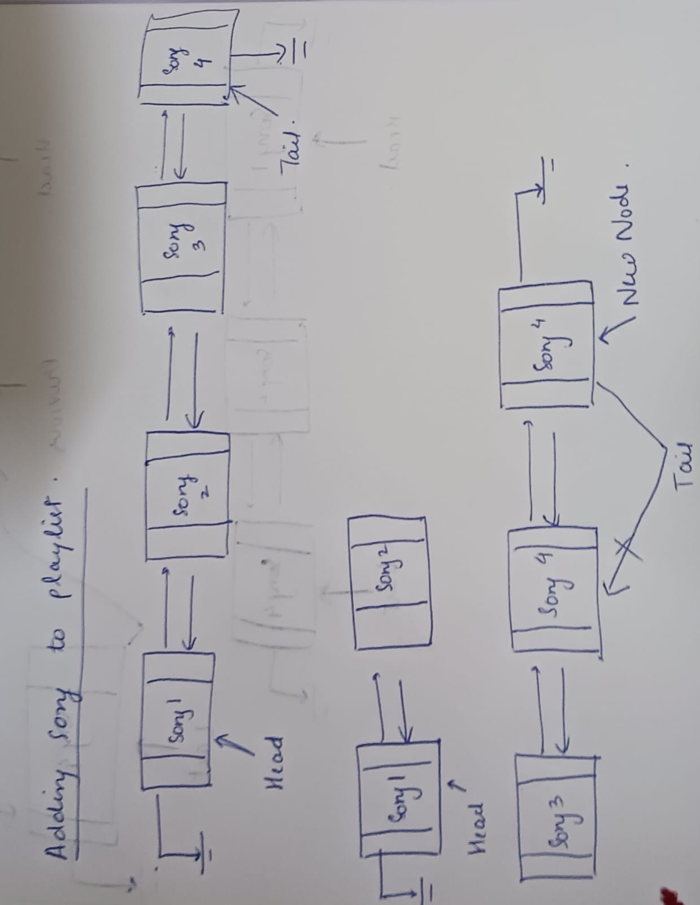

**PUSH PLAYED SONG:**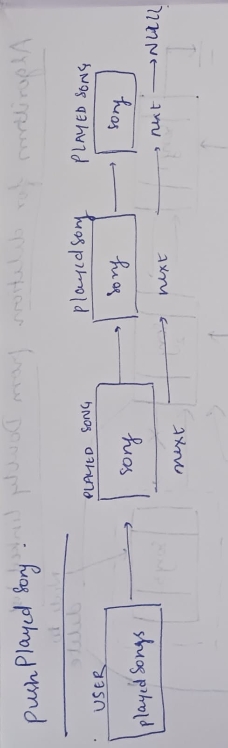

**DELETION FROM DOUBLY LINKED LIST:**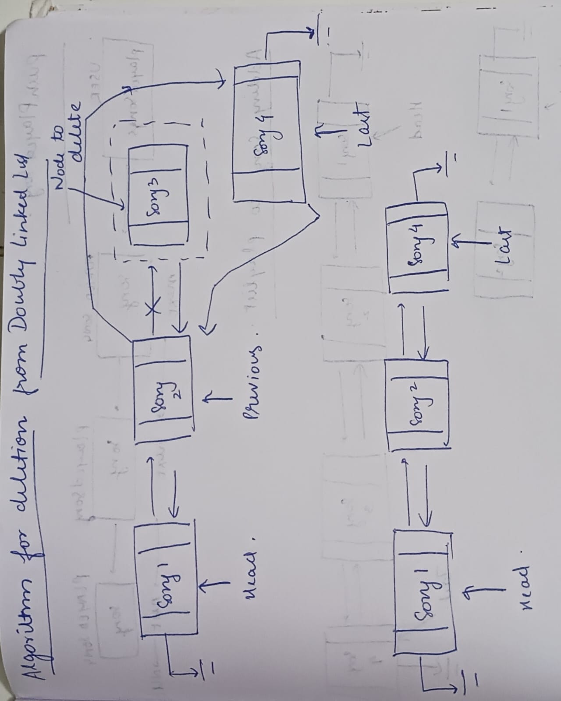

**SHUFFLE PLAYLIST:**